**Create vetical table in power automate for Email and Teams teamplate(Approvals)**

1. Create Array with required table details. As per below screen shot.

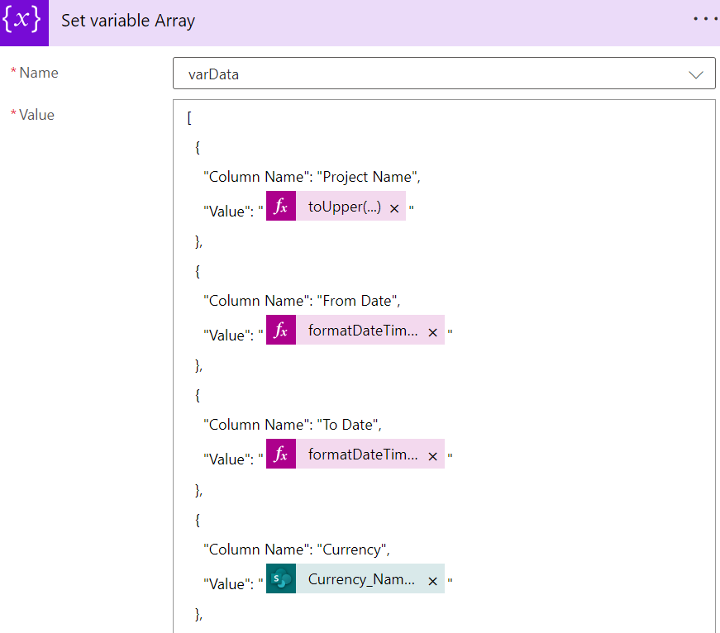

1. Create the parse json to get the data in proper format. As shown below

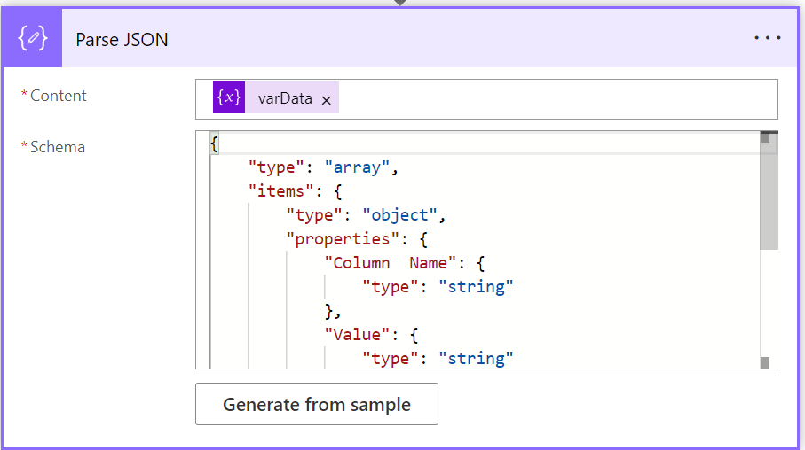

1. Use Select funtion to get data in vertical table format. As below image

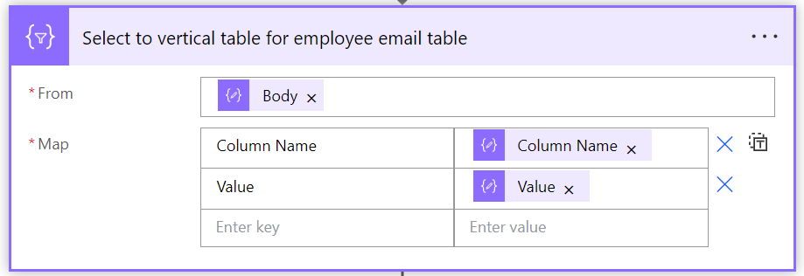

1. Use create Htm table to get table format.

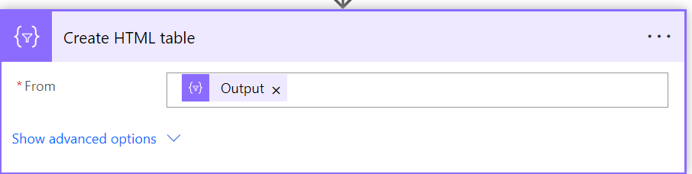

1. Use output from html table in Email

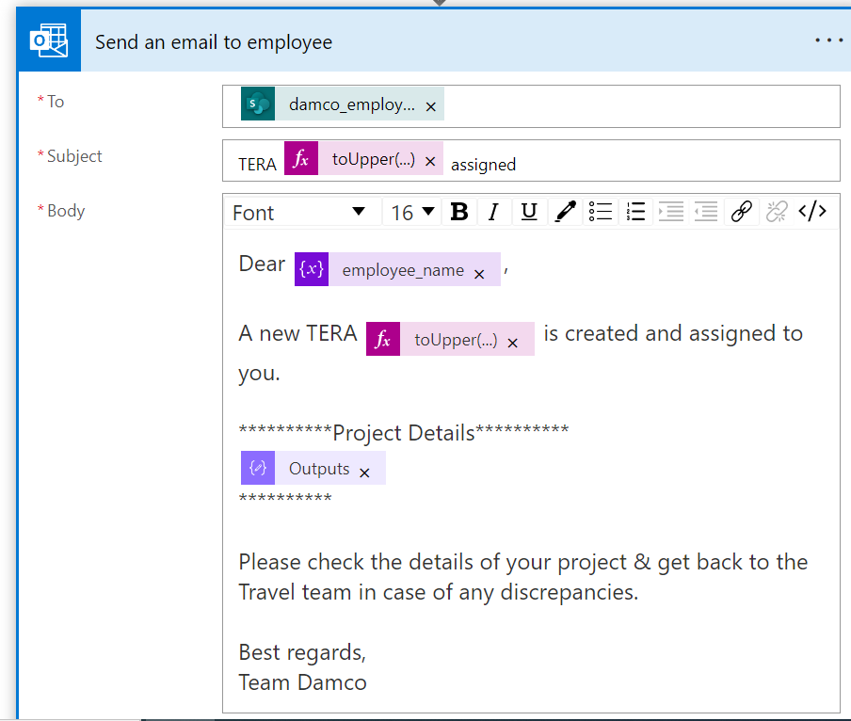

Complete Process:

